**Database Systems Lab - 14CS2012**

**REGISTER NO: UR14CS228**

**DATE: 17-10-2016**

**EXPERIMENT-NO 6**

**Video Link :** [**https://youtu.be/vuTSnC__AOk**](https://youtu.be/vuTSnC__AOk)

**AIM:**

Develop an application for a company to manage its order and supply details using JDBC connectivity

**DESCRIPTION:**

Class.forName("oracle.jdbc.driver.OracleDriver"); //Register the Driver Class

Connection con=DriverManager.getConnection(

"jdbc:oracle:thin:@localhost:1521:xe","system","password"); // Connection

Statement stmt=con.createStatement();

ResultSet rs=stmt.executeQuery("select * from emp");

**Program:**

import java.util.Scanner;

public class Company {

public static void main(String[] args) {

CompanyOperations coop = new CompanyOperations();

Scanner scan = new Scanner(System.in);

int choice;

System.out.println("Database Operation:");

System.out.println("Enter 1 for New Order");

System.out.println("Enter 2 to Modify the order details");

System.out.println("Enter 3 to Delete from order table");

System.out.println("Enter 4 to Search supply details based on Product Id");

System.out.println("Enter your choice of operation");

choice = scan.nextInt();

switch (choice) {

case 1: {

coop.insertQuery();

break;

}

case 2: {

coop.modificationQuery();

break;

}

case 3: {

coop.deleteQuery();

break;

}

case 4: {

coop.search1();

break;

}

default: {

System.out.println("Enter Correct Choice Please.");

}

}

}

}

--------------------------------------------------------------

import java.sql.*;

import java.text.DateFormat;

import java.text.ParseException;

import java.text.SimpleDateFormat;

import java.util.Arrays;

import java.util.Scanner;

import java.util.logging.Formatter;

import java.util.logging.Level;

import java.util.logging.Logger;

public class CompanyOperations {

final String JDBC_Driver = "oracle.jdbc.driver.OracleDriver";

final String DB_URL = "jdbc:oracle:thin:@localhost:1521:XE";

final String USER = "system";

final String PASSWORD = "fish";

Connection conn = null;

Statement statement = null;

Scanner scan = new Scanner(System.in);

void insertQuery() {

try {

try {

Class.forName(JDBC_Driver);//REGISTERING THE DRIVER

} catch (ClassNotFoundException ex) {

Logger.getLogger(CompanyOperations.class.getName()).log(Level.SEVERE, null, ex);

}

try {

conn = DriverManager.getConnection(DB_URL, USER, PASSWORD);// CONNECTION

} catch (SQLException ex) {

Logger.getLogger(CompanyOperations.class.getName()).log(Level.SEVERE, null, ex);

}

int order_id;

int customer_id;

String sql;

System.out.println("Enter order id");

order_id = scan.nextInt();

System.out.println("Enter the order date('DD-MMM-YYYY')");

String order_date1 = scan.next();

SimpleDateFormat df = new SimpleDateFormat("dd-MMM-yyyy");

java.util.Date order_date2 = df.parse(order_date1);

java.sql.Date order_date = new java.sql.Date(order_date2.getTime());

System.out.println("Enter the customer id");

customer_id = scan.nextInt();

sql = "insert into order1(order_id,order_date,customer_id)" + "values(?,?,?)";

PreparedStatement pstatement = conn.prepareStatement(sql);

pstatement.setInt(1, order_id);

pstatement.setDate(2, order_date);

pstatement.setInt(3, customer_id);

pstatement.executeUpdate();

System.out.println("New Row added!");

pstatement.close();

conn.close();

} catch (ParseException | SQLException ex) {

System.out.println(Arrays.toString(ex.getStackTrace()));

System.out.println(ex.getMessage());

}

}

void modificationQuery() {

try {

Class.forName(JDBC_Driver);

conn = DriverManager.getConnection(DB_URL, USER, PASSWORD);

} catch (ClassNotFoundException ex) {

System.out.println("Its a"+ ex.getMessage());

} catch (SQLException ex) {

System.out.println(ex.getMessage());

}

System.out.println("Which column would you like to update? Press 1 for Order Date or 2 for Customer Id");

int choice = scan.nextInt();

System.out.println("Enter the updatable order id");

int order_id = scan.nextInt();

if(choice==1){

try {

System.out.println("Enter the new Date('DD-MMM-YYYY')");

String order_date1 = scan.next();

SimpleDateFormat df = new SimpleDateFormat("dd-MMM-yyyy");

java.util.Date order_date2 = df.parse(order_date1);

java.sql.Date order_date = new java.sql.Date(order_date2.getTime());

String sql = "UPDATE order1 SET order_date = ? WHERE order_id = ?";

PreparedStatement pstatement = conn.prepareStatement(sql);

pstatement.setDate(1,order_date);

pstatement.setInt(2,order_id);

pstatement.executeUpdate();

pstatement.close();

conn.close();

} catch (ParseException ex) {

Logger.getLogger(CompanyOperations.class.getName()).log(Level.SEVERE, null, ex);

} catch (SQLException ex) {

Logger.getLogger(CompanyOperations.class.getName()).log(Level.SEVERE, null, ex);

}

}

else{

try {

System.out.println("Enter the customer Id");

int customer_id = scan.nextInt();

String sql = "UPDATE order1 SET customer_id = ? WHERE order_id = ?";

PreparedStatement pstatement = conn.prepareStatement(sql);

pstatement.setInt(1,customer_id);

pstatement.setInt(2,order_id);

pstatement.executeUpdate();

pstatement.close();

conn.close();

} catch (SQLException ex) {

Logger.getLogger(CompanyOperations.class.getName()).log(Level.SEVERE, null, ex);

}

}

}

void deleteQuery() {

try {

try {

Class.forName(JDBC_Driver);

conn = DriverManager.getConnection(DB_URL, USER, PASSWORD);

} catch (ClassNotFoundException ex) {

Logger.getLogger(CompanyOperations.class.getName()).log(Level.SEVERE, null, ex);

} catch (SQLException ex) {

Logger.getLogger(CompanyOperations.class.getName()).log(Level.SEVERE, null, ex);

}

System.out.println("Enter the order id to be deleted");

int order_id = scan.nextInt();

String sql = "DELETE FROM order1 WHERE order_id = ?";

PreparedStatement pstatement = conn.prepareStatement(sql);

pstatement.setInt(1, order_id);

pstatement.executeUpdate();

pstatement.close();

conn.close();

} catch (SQLException ex) {

Logger.getLogger(CompanyOperations.class.getName()).log(Level.SEVERE, null, ex);

}

}

void search1(){

try {

int p_id1;

try {

Class.forName(JDBC_Driver);

conn = DriverManager.getConnection(DB_URL, USER, PASSWORD);

} catch (ClassNotFoundException ex) {

Logger.getLogger(CompanyOperations.class.getName()).log(Level.SEVERE, null, ex);

} catch (SQLException ex) {

Logger.getLogger(CompanyOperations.class.getName()).log(Level.SEVERE, null, ex);

}

System.out.println("Enter the Product Id");

p_id1 = scan.nextInt();

String p_id = Integer.toString(p_id1);

String sql;

sql = "SELECT * FROM supplier WHERE p_id = " + p_id;

Statement pstatement = conn.createStatement();

ResultSet rs = pstatement.executeQuery(sql);

while(rs.next()){

int s_id = rs.getInt("s_id");

String s_name = rs.getString("s_name");

String gender = rs.getString("gender");

Date s_date = rs.getDate("s_date");

int p_id20= rs.getInt("p_id");

System.out.println(s_id);

System.out.println(s_name);

System.out.println(gender);

System.out.println(s_date);

System.out.println(p_id20);

}

rs.close();

pstatement.close();

conn.close();

} catch (SQLException ex) {

Logger.getLogger(CompanyOperations.class.getName()).log(Level.SEVERE, null, ex);

}

}

}

**Output:**

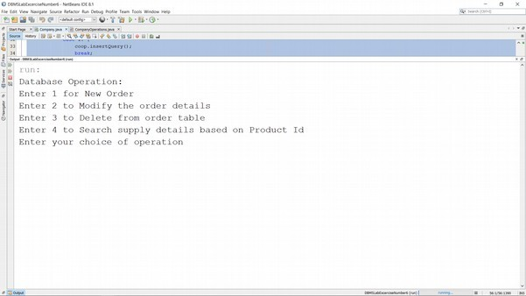

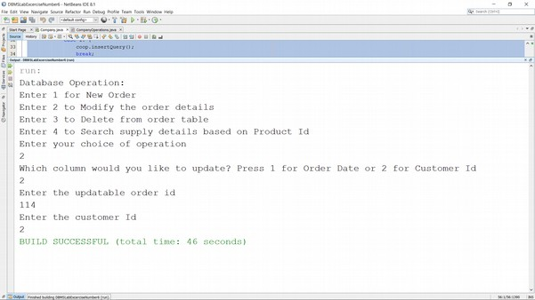

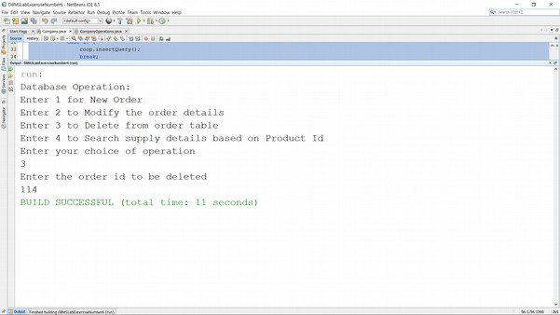

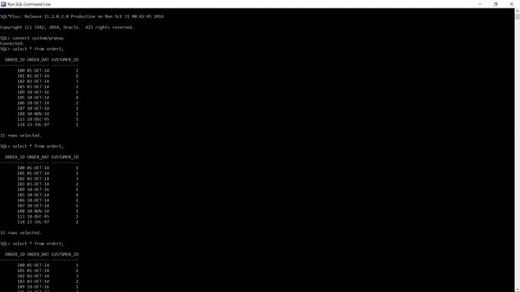

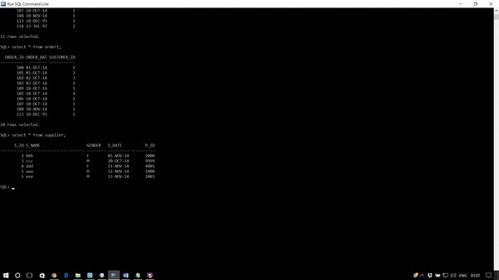

**Result:**

Application Development using JDBC Connectivity was successfully completed.